Pakistan Gaming Network (PGN App)

**Project Task 4: Low­fi Prototyping & Pilot Usability Testing**

Team Members:

**Shehryar Raza (BSCS-13020)**

**Abdul Jalil Mian (BSCS-13062)**

**Mariyah Kaleem (BSCS-13065)**

# **Introduction**

eSports gaming community has been revolutionized throughout the past decade in the world. The gamers for all around the world participate in different kind of tournaments whether they are being played at the International level or local region. Thousands of gamers also tend to create friendly LAN environment on the week-to-week basis to enjoy the moments among their friends.

In Pakistan, the eSports community has grown exponentially in the past couple of months. People from different areas of Pakistan are participating in major tournaments like Softec, Nascon, Battle Arena etc. The number of participants is always increasing every year and this could potentially mean that the Pakistan is on its way to build a strong eSports community within itself.

# **The problem**

Although the number of participants and gamers are increasing in Pakistan, the scenario of eSports and the environment related to it is still underdeveloped. There is no such progress in the eSports sector except for one or two special cases. There are no proper sponsors associated with the gaming tournaments. In addition to that, the biggest problem in the Pakistani eSports sector is the lack of development in the technology and needs of the gamers.

With the help of our survey conducted at multiple gaming zones and gaming organizations, we came to know that the biggest issues that the gamers face are the lack of information about the upcoming events around them. Moreover, they wished to have such a system in which they could have a conversation with the gamers of the same taste around them and later on, they could arrange a LAN meetup.

# **The solution**

To overcome such issues mentioned above, we developed an app for the gamers and the eSports community in Pakistan. The app would notify the users about the nearby upcoming gaming events and also give them the access to create a LAN meetup after discussing it in the related gaming community.

# **Concept sketches**

We decided to make rough sketches for the app. First of all, we started with random ideas about how we can implement such a system which fulfills all the needs of a gamer. Based on the needfindings of the users, we came up with three different designs, all of which had a different focus target.

# **UI Sketches**

We picked top two designs out of three in the concept sketches based on the needfindings and priorities of a user.

The design patterns are as follow.

## **Design 1**

In the first design pattern, we focused on the needs of the gamers based on the surveys. In order to meet the requirements of a user, we implemented the “nearby events” feature. Using that feature, a user can find any gaming event happening nearby him/her. The user can also prioritize the notification based on the area/city/country. Along with that, the organizers can also create their own events on the app which is feasible for them as well as the gamers. The second feature includes the LAN meetup through the community forums. A user can create a LAN meetup and call the gamers through the app community chat.

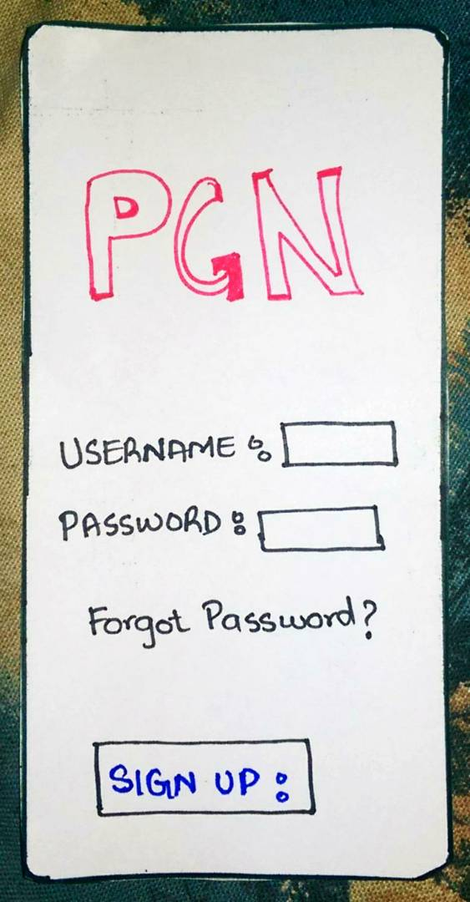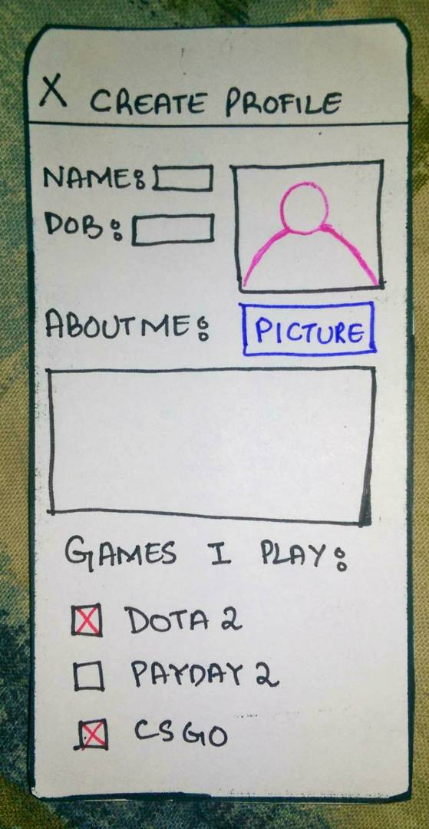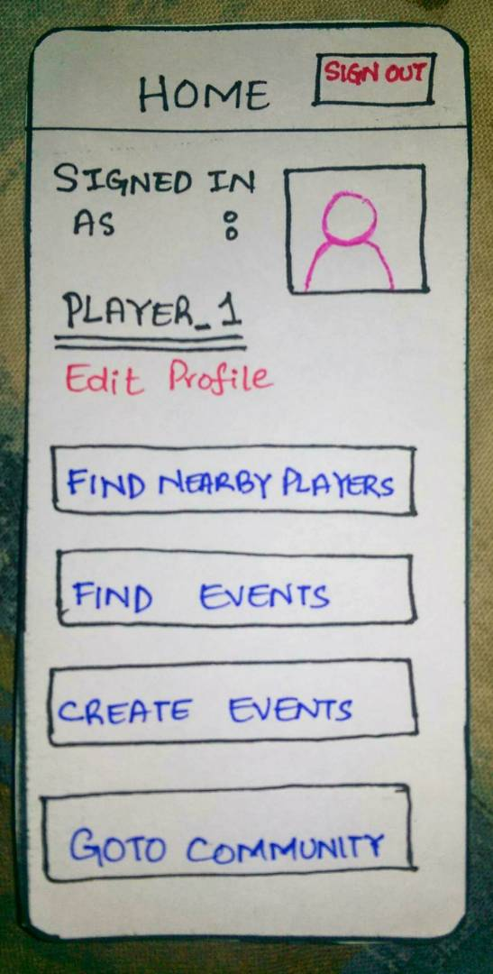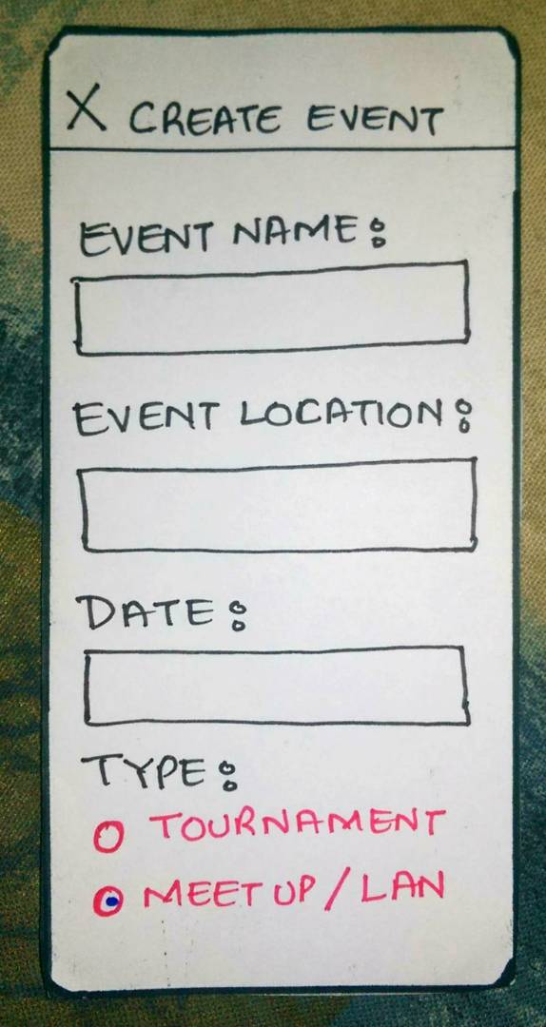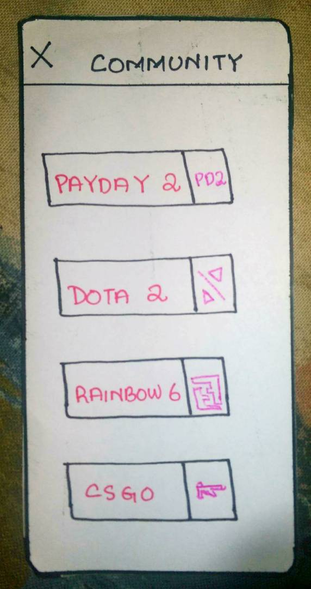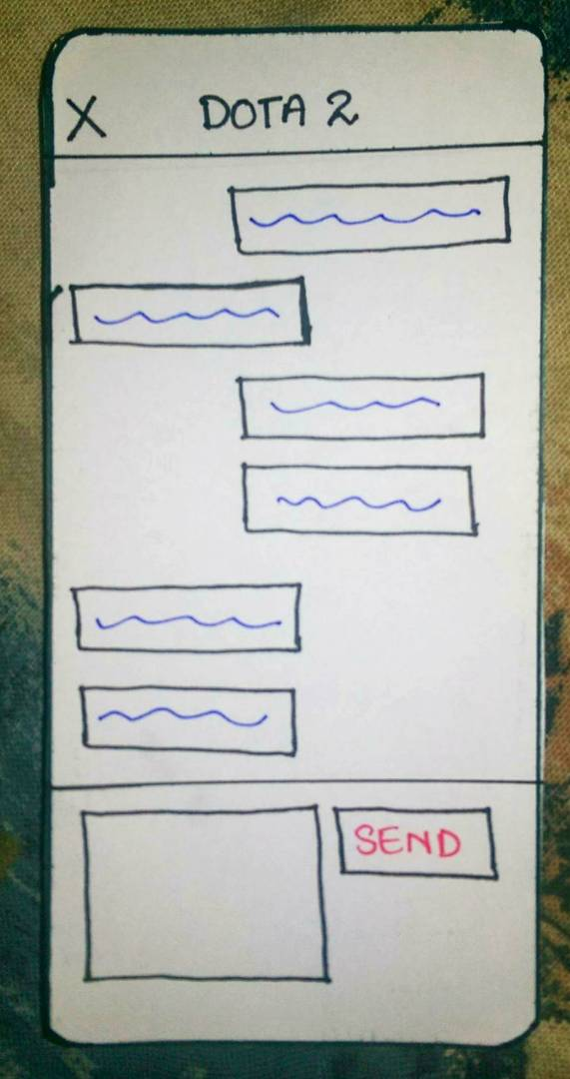

### **Pros**

* Notification of any nearby gaming event
* General LAN meetup
* A big eSports community present on the app
* A very little commitment from the organizer to create the event

### **Cons**

* App might be complicated to use for beginners

## **Design 2**

The second design revolves around the theme selection and feedback section on the app. Considering that different gamers have different taste, we went for the selection of this design. The user can select the theme of the app according to his/her taste and can also provide the valuable feedback through the feedback section.

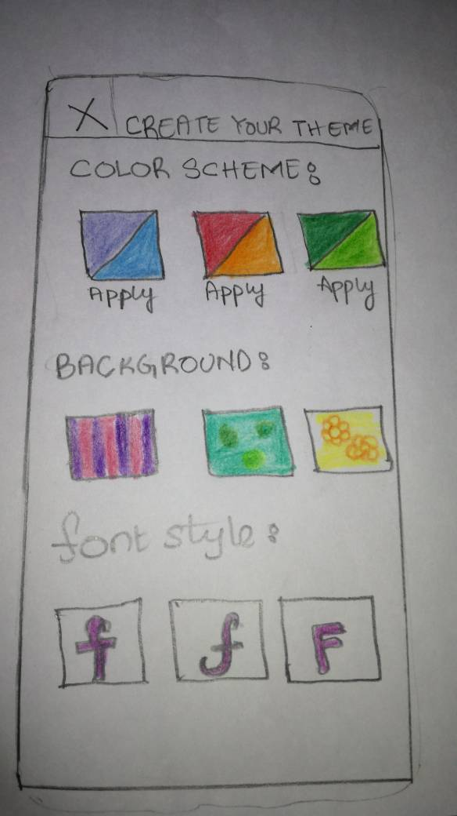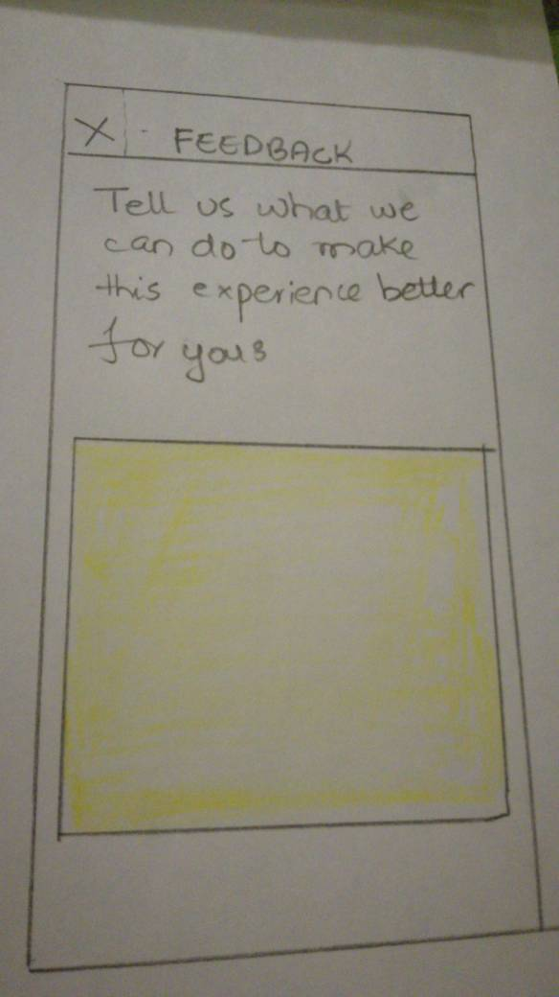

### **Pros**

* The app let you select the theme of your taste
* The Feedback section let the users express their feelings about the app

### **Cons**

* The focus of the design doesn’t suit the entire gaming community as some of them prefer the app with default settings

# **Design Selection Rationale**

We picked the Design 1 because it was fulfilling the needs of the gamers as well as the local organizers who want to arrange a gaming tournament. Moreover, the eSports community on the app let the users interact with each other in a feasible way.

# **UI Storyboards**

Our three tasks were as follow.

* Simple: Find upcoming events
* Medium: Find players nearby and interact with other users
* Complex: Create events

We created the Storyboard using the online prototype application, “marvelapp.” The interactive version of the tasks can be found [here](https://marvelapp.com/1hj21af/screen/27852205).

# **Testing phase**

We went to Battle of the Heroes 2017 gaming tournament held at the University of Lahore on 30th April. We tested our product on 25 gamers and the participants present there for the gaming event.

We started with the simple task i.e. Find upcoming events. Around 95% of the participants found it very easy to use the feature as well as they were appreciating such kind of step in the eSports community Pakistan. Overall, the score we gave to this task is 0 (no problem).

Later, we tested the Medium task of the app i.e. Find players nearby and interact with other users. About 70-75% of the participants appreciated the idea because, in their opinion, it will promote the eSports community culture in Pakistan. The rest of the participants preferred to play alone at home. The calculated score for this task is 1 (cosmetic problem).

The last task was to create events. We tested this task on the organizers of the tournament. They responded well to the feature as in their opinion, it will help them out to spread out the words in the big eSports community. However, they responded in a normal way when the verification about their event was asked on the app. Overall, we gave this task the score 1 (cosmetic problem).